How does the web app work?

This app turns a folder of economics papers into a structured set of parameter estimates and extracts information on how these estimates are calculated. It can generate a table containing the actual parameters estimated in the paper (based on the keywords defined on the main page) and filter them based on an extra set of keywords defined by the user. Its main application is generating meta-analyses, and in the current study, it was used to extract price and income elasticities from agri-econ papers focusing on specific African countries.
In this app, elasticity estimates and study characteristics were collected with this semi-automated pipeline that combines deterministic text processing, LLMs, and a step that includes researcher verification (Figure 1). The app has four phases: document processing, multi-stage screening, coding of estimates and study characteristics, and quality control.

Figure 1. Workflow for extracting elasticity estimates from primary studies
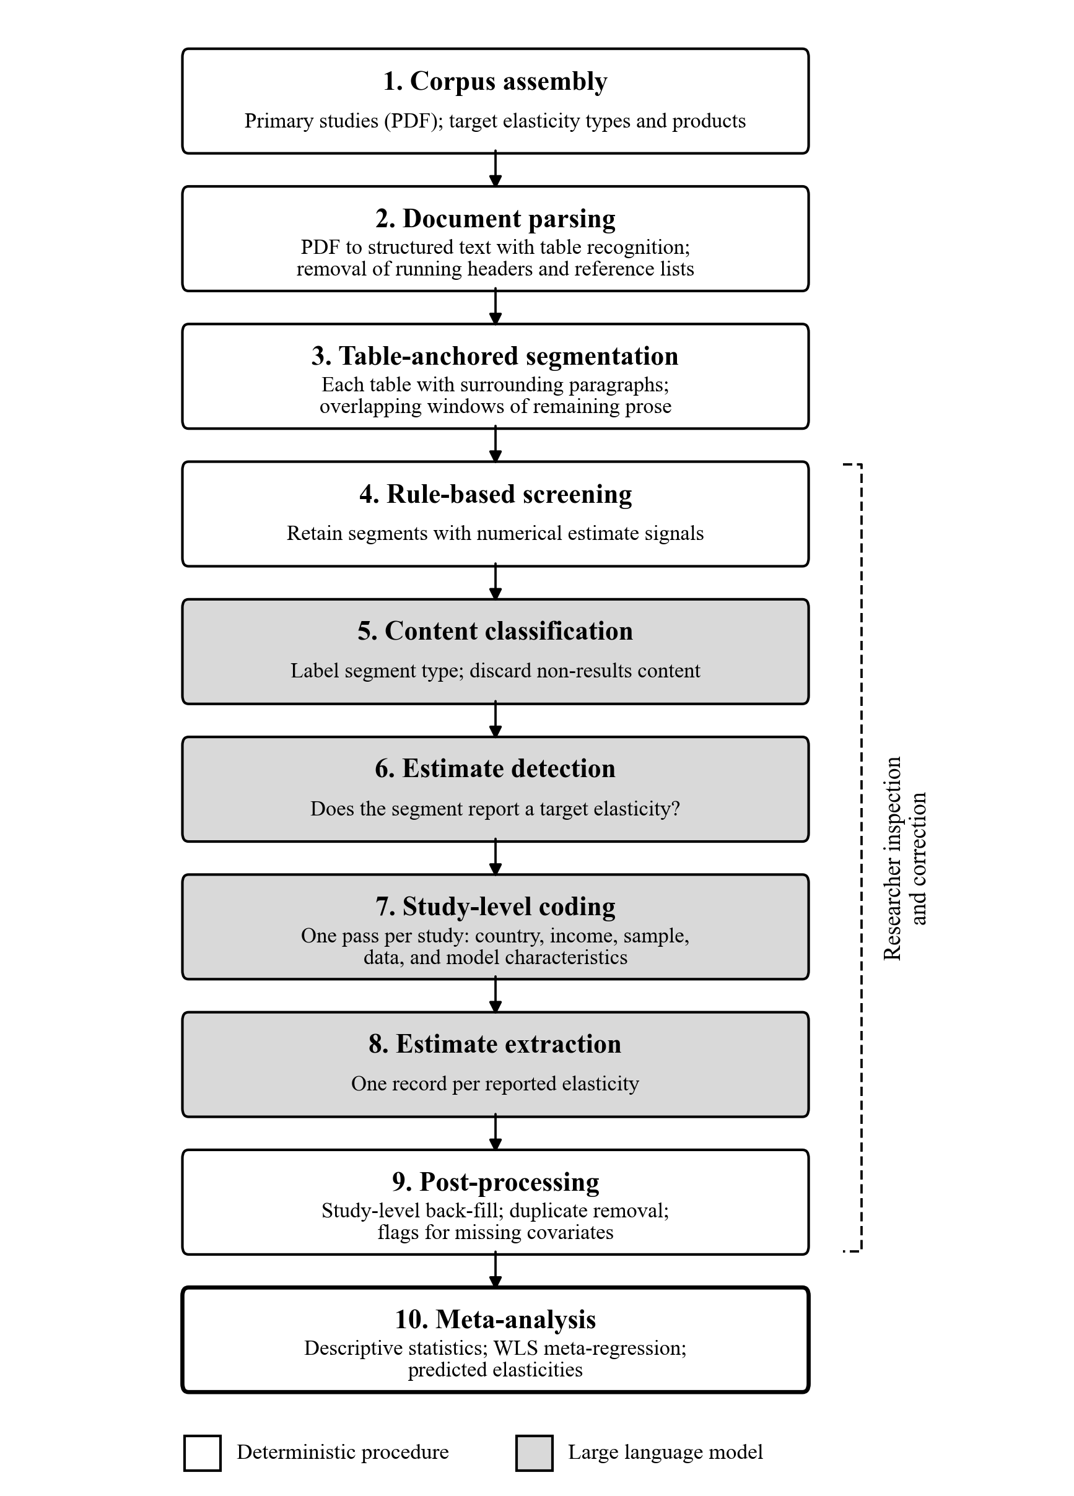
The pipeline first takes the full paper and breaks it into chunks using a deterministic approach to eliminate parts that do not include any parameter estimates, such as the reference list, acknowledgements, etc. Additionally, this part helps group the chunks into standard academic paper parts, which enables the later-stage LLMs to better process the text.
Segments of the text are then passed through three successive filters. First, a rule-based screen retains a segment if it contains at least one of the following: a decimal number in parentheses (typically a standard error or t-statistic), significance markers with decimal numbers, a decimal number together with an estimation-related term (for example, "coefficient", "elasticity", "standard error", or "confidence interval"), or a table. The abstract in this step is exempt from the screening process as it contains valuable information about the paper which can be used as context for the LLM.
Second, a lower-cost LLM (Haiku 4.5) assigns each retained segment to one or more content categories (regression table, results text, methodology, data description, literature review, or other) and indicates whether the segment should be kept or not; In this step, segments that are marked for exclusion, such as summaries of earlier literature, are discarded. Third, the same model judges whether each remaining segment reports a point estimate of one of the target parameters for one of the target categories (defined by the user in the first step). Only segments with a positive judgment proceed to the next step of coding.
It is important to note that at each stage the researcher can modify the results generated by the deterministic grouping and the LLM coding.
The main data extraction is performed by a more capable LLM (Sonnet 5 in this paper’s case) in two passes. In the first pass, the model codes study-level characteristics once per study, using the abstract and the segments classified as methodology or data description. These characteristics are country or region, sample period, data frequency, number of observations and cross-sectional units, data source, real per capita income, level of aggregation, geographic scope, urban–rural coverage, data structure, price measure, conditional or unconditional specification, number of budgeting stages, demand system, estimation method, inclusion of demographic controls, publication status, language, and the number of goods in the demand system (due to this paper’s focus on country-level meta-analysis, the prompts were engineered to extract country-related data).
In the second pass, the model codes each screened segment, given the segment text, the study abstract, and the list of target parameters set by the user. For every reported estimate that matches a target, it returns the parameter type, the category, and the wording used in the study, the point estimate and its measure of precision, the functional form of the estimated relationship, and the estimate's location in the table. In this study, each parameter category is additionally mapped to one of the nine product groups of Chen et al. (2016): grains and vegetables, meat and eggs, edible oil, aquatic products, fruits, sugar, dairy, tobacco, and alcohol by adding a chunk to the prompt.
Three quality checks are applied to the coded estimates. First, when the same estimate is recorded twice from the same study, once with full precision and once rounded (for example, from a table and from the accompanying text), the rounded duplicate is removed. Second, when estimates for which real per capita income or the budget share, or, for conditional elasticities, the group expenditure or group own-price elasticity was not reported, the corresponding cells were left missing and flagged for review; hence, no values were imputed. Third, the researcher reviewed the coded dataset against the source documents and corrected, added, or removed estimates where necessary. To help researchers save time, the app also locates the exact page and paragraph where the parameters are extracted.
The pipeline records the functional form of each estimate but does not convert between functional forms. For instance, conditional elasticities were not converted to unconditional elasticities, nor Hicksian elasticities to Marshallian elasticities; all estimates enter the analysis as reported.
Finally, a CSV file containing all the parameters and related information is prepared for the researcher’s review. Once the file is ready, the researcher can either download the file and run analysis in a separate environment or use the app’s built-in meta-analysis tools to extract descriptive tables and run regressions. The current version of the app includes equations that are used in this paper; however, based on the study’s needs, these equations can be modified.

